

**Senior Design Project**

**Design of An Automatic Solar Panel Debris Removing System**

**A.S.C.D.R.S**

ENGE476 Senior Design Project I

Department of Engineering and Aviation Sciences

University of Maryland, Eastern Shore

Tochi Chukwu

Joshua Orebiyi

Project Advisor, Dr. Lei Zhang

Submitted

Mon. 25, 2018

List of Contents

List of Contents 2

List of Figures 4

List of Tables 5

Abstract 6

1. Introduction 7

1.1 Backgound/Motivation 7

1.2 Objective 8

1.3 Design Requirements 9

1.4 Design Constraints 9

1.5 Design Methods 9

2. Project Description 10

2.1 System Description 10

2.2 System Diagram 11

2.3 System Functions 13

3. Implementation Plan 14

3.1 Tasks 14

3.2 Team Organization 16

3.2.1 Responsibility of Tochi Chukwu. 16

3.2.2 Responsibility of Joshua Orebiyi. 16

3.3 Timeline/Milestones/Delivery Plan 16

4. Implementation 18

4.1 Implementation of Task 1. Conceptual Design. 18

4.2 Implementation of Task 2. Kinematic Analysis. 18

4.2.1 Equations of Position 18

4.2.2 Equations of Velocity 20

4.2.3 Equations of Acceleration 21

4.3 Implementation of Task 3.Kinetic Analysis. 23

4.4 Implementation of Task 4. Working Model 2D. 23

4.5 Implementation of Task 5. Design formulation. 23

4.6 Implementation of Task 6. Computer Aided Design. 23

4.7 Implementation of Task 8. Finite Element Method Stress Analysis. 23

5. Conclusion. 24

Acknowledgement 25

Appendix 26

A. Component Specs 26

1. Specs of Arduino Due 26

2. Specs of Raspberry Pi 26

B. Source Code. 26

1. Source Code of Graphic User Interface 26

2. Source Code of Robotic Arm 26

REFERENCES 27

List of Figures

Table 1. Project Timeline and Delivery Plan 12

List of Tables

Abstract

The dust particles accumulating on the solar panel will decrease the slar energy reaching the solar cell, therby reducing the overall power output. In this report, the problem is reviewed and the method for debris removal is discussed. An automatic cleaning device is developed and features a versatile platform which travels the entitre length of a panel. The automatic machine will provide a favourable result and shows that such a system is viable. In conclusion it ii found that the automatic machine cleaning is practical and can help in maintaining the solar panel efficiency also and reduce the maintenance cost.

1. Introduction

## Backgound/Motivation

A solar panel includes an array of solar cells covered by a transparent protective cover through which sunlight transmits to reach the solar cells. Solar energy is one of the most feasible sources of renewable energy but because of accumulation of: dust, soil, tree debris, sand, moss, dirt, sap, bugs, bird droppings, water spots or mold, the panel efficiency is significantly reduced by up to 25%. The purpose of this project was to design and develop the cleaning solar panels automatically to increase the efficiency and energy output from these panels. It is shown that panel efficiency may be reduced by up to 5% to 10% from build up dust particles alone. Adding in other factors such as falling leaves, bird dropping and water streaking, the efficiency of these panels can be further reduced to as much as 10 – 30%.

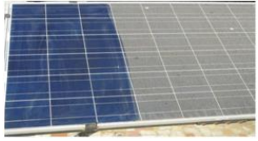

Figure 1 Solar Panel covered in Debris

Our studies show links of reduction in output. We narrowed our focus to Perdue’s solar plant. There were several considerations taken when designing the system. Firstly, in the case of commercial use, solar panels are usually placed on an angle from the ground to receive the maximum amount of sunlight. Because of this, to clean these solar panels individuals would have to climbing up on to the roof to clean the panels, which can be very hazardous or risky. The other option would be to hire a company to do it for them. The system being designed should be automatic to prevent having to climb up onto the roof or terrace and allowing for the solar panels to be cleaned by others. Another factor taken into consideration was that solar panels tend to be placed in areas where there is a lot of sunshine and very little rain. Therefore, we would not be depending upon rainfall to clean the panels, but water usage, for self-cleaning, in these areas may be limited as well. Also, there needed to be a way of determining when to clean the solar panel since having it cleaned all the time would be equally a waste of power or energy.

Additionally, we could not depend on there being a reduction of power from the panels as a method of determining when it should be cleaned since a whole cloudy day would also result in a reduction in absorption of solar rays. The accumulation of dirt on solar panels ("soiling") can have a significant impact on the performance of PV systems in regions where rainfall is limited for a dry season of several months. This effect is magnified where rainfall is absent in the peak-solar summer months, such as in California and the Southwest region of the United States. This paper describes the effects of soiling on energy production for large grid-connected systems in the US and presents a model for predicting soiling losses. The adverse impact of soiling (dust deposition) on solar collectors, and the mitigation of the related energy yield losses, are the main scopes of this paper. While soiling related losses have been studied more extensively for flat plate photovoltaic (PV) panels, this study focuses primarily on the impact of dust accumulation on concentrated photovoltaic (CPV) and concentrated solar power (CSP) systems. We report on different methods used for cleaning solar collectors: Natural cleaning by rain and snowfall, Manual cleaning by water and detergent, and an emerging method of dust removal by electrodynamic screens (EDS). Development of ED’s technology as an automated, low-cost dust removal method which does not require any water or manual labor is presented.

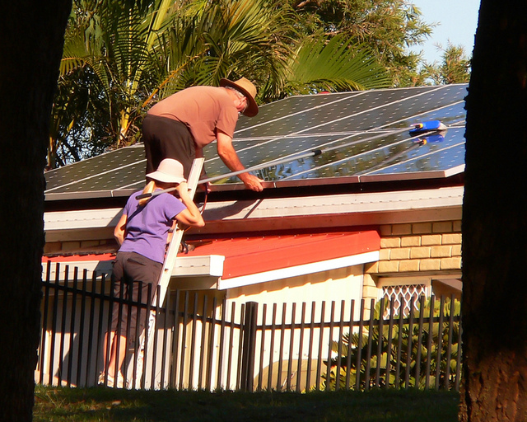

Figure 2 Safety Hazards

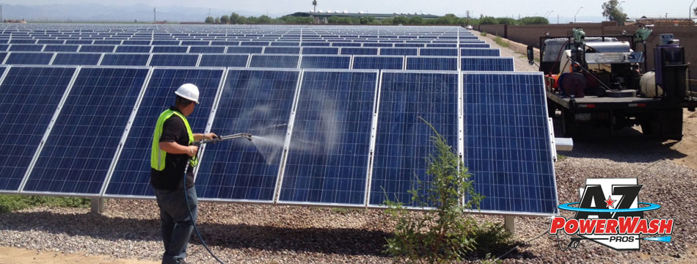

Figure 3 Manual Labor

## Objective

The purpose of this project is to design an automatic solar panel debris cleaner to improve the efficiency and reduce maintenance cost of solar.



Figure 4 Estimated Cost Perdue Spends on Cleaning Solar field Yearly

## Design Requirements

1. The machine should capable of cleaning diverse types of debris on solar panel based on the thickness and density.
2. The operational time for the machine to effectively clean the rover should be 30 minutes per 64.6in row.
3. The whole machine frame should weigh less than 100 lbs.
4. The machine brush should be able to increase the solar panel efficiency to 80% from its initial 30% reduction
5. The machine should be able to withstand temperature as high 85 degree Fahrenheit and as low as 25 degree Fahrenheit.
6. The motors should drive the machine with battery lasting up to 3hours
7. The machine should only be used on a dry ground surface.

## Design Constraints

The design of the automatic machine could be limited by the cost available to design the machine, the area of work space available for the machine to move through is also a constraint. An important constraint is the maximum weight Perdue’s solar panel can handle and the stability of the solar panels structure.

* Area of work space available
  + 17’-3”
* Weight of Apparatus
  + <100lbs
* Cost (Less than $500)
* Weight of apparatus on solar panel
* Static Stability of Solar Panel Structure

## Design Methods

Figure 5 Design Model Chart

As shown in Figure 5, our machine design has six main steps. The first step is to design a conceptual model of the machine. The second step is to calculate the kinematic and kinetics of the machine. Once the first two steps are complete then the CAD model of the machine will be designed. The next step is to design the rover and analyze the stability. Then the prototype of the machine will be produced. The last step is the delivery of the machine to Perdue.

1. Project Description

## System Description

* Rotary and coil brushes are mounted on automated on the crank. Regardless of brush size or speed, the brush balance was implemented to ensure complete surface contact.
* Wheels here are required for the movement of the motor over the complete panel. Through this wheel, the machine will be able to move all throughout the panel.
* Motors are used for the rotational purpose of the machine. The other types of motor are being used to rotate the cleaning brushes, which helps in the cleaning purpose.

Arduino 101 is a microcontroller board based on theATmega328P. It has 14 digital input/output pins, 6 analog inputs, a 16 MHz quartz crystal, a USB connection, a power jack, etc., It contains everything needed to support the microcontroller. The role of the Arduino here is that it is been made to control the machine and working of the machine by simple programming. The Arduino 101 was used because it has a built in Bluetooth low energy and IMU.

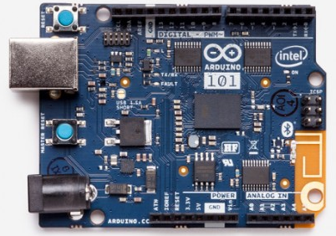

Figure 6 Arduino 101 Microprocessor

Adafruit 1438 Motor Shield v2 is the best easiest way to control DC motors servos and steppers using the Arduino 101. This shield has the ability to drive up to 4 bi-directional DC motors or 2 stepper motors. The TB6612 MOSFET driver with 1.2A per channel current capability used with the shield. The 1438 motor shield with PWM driver chip onboard handles all the motor and speed controls over I2C. This motor shield is compatible with Arduino UNOA Light Dependent Resistor is a resistor that changes in value according to the light falling on it.

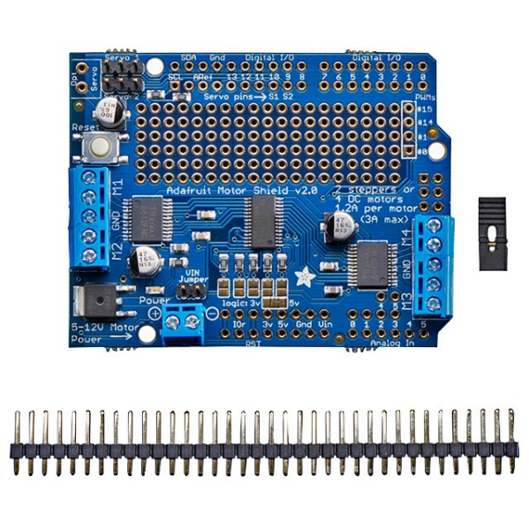

Figure 7 Adafruit 1438 Motor Shield v2

## System Diagram

The algorithm for implementation of cleaning arrangement and machine mechanism has been explained by the following flow charts. At first using the LDR the light intensity through the panel will be monitored. If there is any deviation of intensity on the panel the motor tends to rotate to clean the dust accumulated on panel.

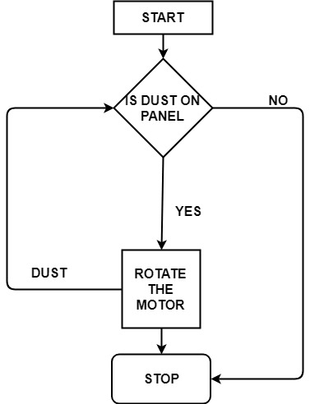

Figure 9 System Algorithm

After the dust is cleared, the rotation of the motor will be stopped. Hence the cleaning operation will be completed. The next algorithm is the machine mechanism, Initially, the robot stationed at the panel end waits the user start command. Once the command is received, the brushes start working and then the machine starts moving in one direction while cleaning the panel. During the operation, the machine keeps moving at constant speed until the sensors signal reaching the panel edge at which point the robot slows down and stops.

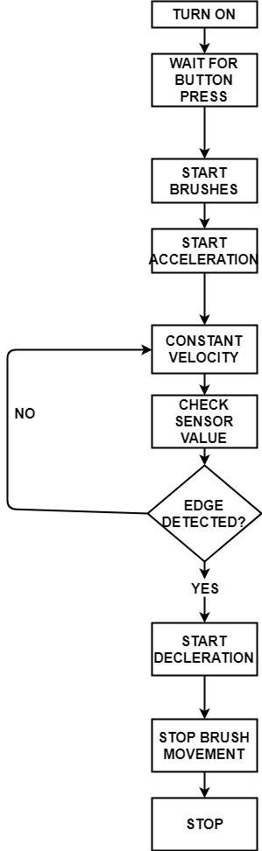

Figure 10 System Process

## System Functions

1. The machine will be controlled by battery
2. We will attach roller brush with soft material and roller brush rotated on the panel surface
3. After that wiper again clean the water particle which remains on the surface.
4. When the caller press a button, first the message will show on the display of the device with the caller, also the message will be coded together with its ID and send to the callee.
5. Implementation Plan

## Tasks

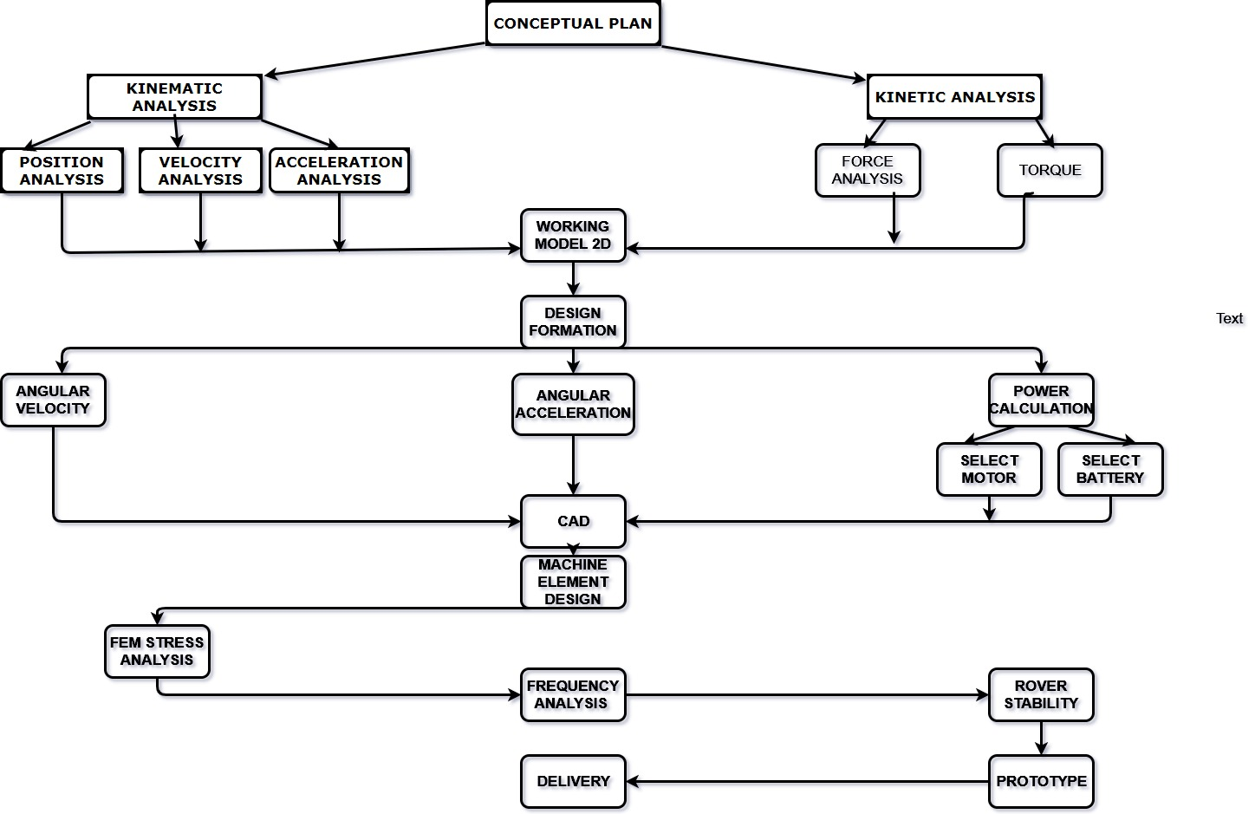

Figure 11 Implementation Task Plan

* Task 1. Conceptual Design.
* Task 2. Kinematic Analysis.
  + Subtask 2.1. Position Analysis.
  + Subtask 2.2. Velocity Analysis.
  + Subtask 2.3 Acceleration Analysis.
* Task 3. Kinetic Analysis.
  + Subtask 3.1. Force & Torque Analysis.
* Task 4. Verify Task 2 & 3 Using Working Model 2d.
* Task 5. Design Formation.
  + Subtask 5.1. Angular Velocity & Angular Acceleration.
  + Subtask 5.2. Angular Acceleration.
  + Subtask 5.3. Power Calculation.
    - Subtask 5.3.1. Select Motor.
    - Subtask 5.3.2. Select Battery.
* Task 6. Computer Aided Design.
* Task 7. Fem Stress Analysis.
* Task 8. Rover Design.
* Task 9. Prototype.
* Task 10. Delivery.

## Team Organization

### Responsibility of Tochi Chukwu.

* Task 1.
* Task 4.
* Task 5.3.1 & 5.3.2
* Task 6.
* Task 7.
* Task 8.
* Task 10.

### Responsibility of Joshua Orebiyi.

* Task 2.
* Task 3.
* Task 5. Subtask 5.1,5.2 & 5.3
* Task 6.
* Task 8.
* Task 9.
* Task 10.

## Timeline/Milestones/Delivery Plan

1. Project Timeline and Delivery Plan

|  |  |  |  |
| --- | --- | --- | --- |
| Time | Task | Comments | Responsible Personnel |
| Week 1-9 |  | Proposed different projects | Tochi Chukwu & Joshua Orebiyi |
| Week 10 | Task 1 | Design a conceptual model | Tochi Chukwu & Joshua Orebiyi |
| Week 11 | Start Subtask 2.1, 2.2 & 2.3 | Analyze the kinematics of the machine to calculate the position, velocity and acceleration analysis | Joshua Orebiyi |
| Week 12 | Cont. Subtask 2.1, 2.2 & 2.3  Start Subtask 3.1 | Analyze the kinematics of the machine to calculate the position, velocity and acceleration analysis.  Start kinetic analysis of machine | Joshua Orebiyi  Tochi Chukwu |
| Week 13 | Subtask 2.1, 2.2 & 2.3 | Continued kinematic analysis | Joshua Orebiyi & Tochi Chukwu |
| Week 14 | Finish Subtask 2.1, 2.2 & 2.3  Continued Subtask 3.1 | Finish and finalize kinematic analysis.  Continued Kinetic analysis. | Joshua Orebiyi  &  Tochi Chukwu |
| Week 15 | Start 4 | Verify completed task 2 & 3 using working model 2D. | Tochi Chukwu |
| Week 16 | Cont. Task 4 | Verify completed task 2 & 3 using working model 2D. | Tochi Chukwu |
| Week 17 | Cont. Task 4 | Verify completed task 2 & 3 using working model 2D. | Tochi Chukwu  &  Joshua Orebiyi |
| Week 18 | Finish Task 4 | Updated and completed working model 2d design. | Tochi Chukwu  &  Joshua Orebiyi |
| Week 19  &  Week 20 |  | Update Computer Aided design  &  Order machine components  &  3D print rover chassis | Tochi Chukwu  &  Joshua Orebiyi |
| Week 21 | Start subtask 5.1 & 5.2 | Start angular velocity and angular acceleration calculations. | Joshua Orebiyi |
| Week 22 | Start subtask 5.3 | Start power calculations and start research for motor and battery. | Tochi Chukwu |
| Week 23 | Finish 5.1 &  5.2  Finish subtask 5.3 | Finish angular velocity and angular acceleration calculation.  Finish & Finalize research on motor and battery. | Joshua Orebiyi  Tochi Chukwu |
| Week 24 | Task 6 | Final updates to computer aided design | Tochi Chukwu  &  Joshua Orebiyi |
| Week 25 | Start Task 7 | FEM stress analysis | Tochi Chukwu  &  Joshua Orebiyi |
| Week 26 | Finish Task 7 | Verification of FEM stress analysis | Tochi Chukwu |
| Week 27 | Start Task 8 | Rover Design | Tochi Chukwu  &  Joshua Orebiyi |
| Week 28 | Task 9 | Build Prototype  &  Update Presentation Slides | Tochi Chukwu  &  Joshua Orebiyi |
| Week 29 | Finish Task 8 | Rover Design | Tochi Chukwu  &  Joshua Orebiyi |
| Week 30 | Task 9 | Build Prototype | Tochi Chukwu  &  Joshua Orebiyi |
| Week 31 | Task 9 | Build Prototype | Tochi Chukwu  &  Joshua Orebiyi |
| Week 32 | Task 10  Work on report | Finish all documentations and report for presentation. | Tochi Chukwu & Joshua Orebiyi |

1. Implementation

## Implementation of Task 1. Conceptual Design.

According to Dr. Payam Matin, one of the team’s mechanical engineering advisors, before were able to start the design of the system we needed to see if our idea was practical. After receiving the blueprints for Perdue’s Solar field, we had to design an apparatus that would be able to clean the entire surface of the solar panel using the given dimensions. After drawing a model of the system, we saw that there were 4 main variables that we need to design our apparatus for. The variables we had to solve for were the length of the crank rod (r2), the length of the connecting rod (r3), the distance of crank from the edge of solar panel (and the height of the crank off the ground (. We used this variables to test different arbitrary values that would give us a set of parameters that would have the crank rod be able to spin in a full 360° motion without the crank rod making contact with the ground, without the crank rod making contact with the solar panels on each sides of the work space, without the connecting rod making contact with the solar panel, and also have the brush reach from end to end of the solar panel. Upon deriving numbers for these variable that cause all these criteria to be met they we could start the design of the apparatus.

|  |  |
| --- | --- |
| Variables | Lengths (in) |
| r2 | 54 |
| r3 | 144 |
|  | 60 |
|  | 76 |

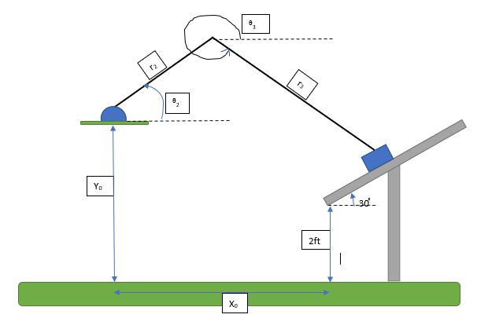

Figure 12 Diagram of Conceptual Design Variables

## Implementation of Task 2. Kinematic Analysis.

|  |  |  |
| --- | --- | --- |
| Variable | Description | Units |
|  |  | Inches |
|  | Angle of the solar panel () | Radians |
| r2 | Length of crank rod | Inches |
| r3 | Length of connecting rod | Inches |
|  | Position of crank rod with respect to solar panel | Radians |
| (3-) | Position of connecting rod with respect to solar panel | Radians |
| 2 | Angular velocity of crank rod | Rad/sec |
| 3 | Angular velocity of connecting rod | Rad/sec |
| 2 | Angular acceleration of crank rod | Rad/s^2 |
| 3 | Angular acceleration of connecting rod | Rad/s^2 |

### Equations of Position

After drawing our model, we used this image to be able to determine the position of the brush by using the angle of the solar panel as the reference angle and deriving the equations in the x domain and the y domain. The equations that we started with were Equation 1.

***Position Equations***

After deriving Equation 1 we simplify our equation in terms of (3-) because the motor would be added to the crank rod. So, you take one equation solve for (3-) and substitute that into the other equation to get position in terms of (2-).

***Solve for***

***Substitute***

Now the equation is in terms of (2-) and can be solved for the position of the brush by just knowing the angle of the crank rod.

### Equations of Velocity

To be able to determine the velocity of the brush we had to take the derivative of Equation 1 to give us Equation 2

***Velocity (derivative of position)***

After solving for velocity, the next step was to use Equation 2 to solve for 3. We derived equation 2 we simplify our equation in terms of 3 because the motor would be adding the crank rod. So, you take one equation solve for 3 and substitute that into the other equation to get position in terms of 2.

***Solve for***

***Substitute***

Now the equation is in terms of 2 you can solve for the velocity of the brush by just knowing the angular velocity of the crank rod.

### Equations of Acceleration

Solving for the acceleration requires taking the derivative of velocity. After solving for Equation 2 we then took the derivative of those equations to get Equation 3

***Acceleration (derivative of Velocity)***

After deriving Equation 3, we simplify that equation by assuming steady state. We assume stead state because our motor is going to be moving at a constant velocity cause the angular acceleration to be 0 in both the crank rod and the connecting rod.

***Steady State***

***,***

After assuming steady state, we take the equations derived and solve for.

After deriving Equation 3 at steady state, we simplify our equation in terms of because the motor would be added the crank rod. This causes the acceleration of the brush to be in terms of the angular velocity of the crank rod. Then we substituted that into the other equation to get angular acceleration in terms of.

***Solve for***

***Substitute***

Now that the equation is in terms of you can solve for the acceleration of the brush by just knowing the angular velocity of the crank rod by using the equation in Figure 11.

## Implementation of Task 3.Kinetic Analysis.

### Force Analysis

Dynamic force analysis involves the application of Newton’s three laws of motion, which are:

* A body at rest tends to remain at rest and a body in motion at constant velocity will tend to maintain that velocity unless acted upon by an external force.
* Tile time rate of change of momentum of a body is equal to the magnitude of the applied force and acts in the direction of the force.
* For every action force there is all equal and opposite reaction force.

The second law is expressed in terms of rate of change of momentum, **M** = mv, where m is mass and **v** is velocity. Mass *m* is assumed 10 be constant in this analysis. The time rate of change of *m***v** is *m*a. Where **a** is the acceleration of the mass center.

**F** is the resultant of all forces on the system acting at the mass center.

We can differentiate between two subclasses of dynamics problems depending upon which quantities are known and which are to be found. The "forward dynamics problem" is the one in which we know everything about the external loads (forces and/or torques) being exerted on the system, and we wish to determine the accelerations. Velocities and displacements, which result from the app1ication of those forces and torques. This subclass is typical of the problems you probably encountered in an introductory dynamics course, such as determining the acceleration of a block sliding down a plane, acted upon by gravity. Given **F** and *m*, solve for **a**.

The one, which gives the most information about forces internal to the mechanism, requires only the use of Newton's law as defined in equations. These can be written as a summation of all forces and torques in the system.

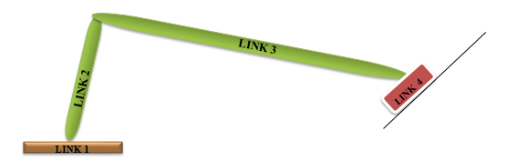

Figure 13 Crank Slider Mechanism

It is also convenient to separately sum force components in *X* and *Y* directions. With the coordinate system chosen for convenience. The torques in our two dimensional system are all in the Z direction. This lets us break the two vector equations into three scalar equations:

These three equations must be written for each moving body in the system which will lead to a let of linear simultaneous equations for any system. The set of simultaneous equations can most conveniently be solved by a martial method.

The figures below will show a crank linkage. All dimensions of link lengths, link positons. Locations of the links' *CGs.* linear accelerations of those CGs and link angular accelerations and velocities have been previously determined from a kinematic analysis. We wish to determine the forces at the joints and the driving torque needed on the crank to provide the specified accelerations. A kinematic analysis was previously done in order to determine all position. velocity, and acceleration information for the positions being analyzed. This linkage has three moving links. Equation provides three equations for any link or rigid body in motion. We should expect to have nine equations in nine unknowns for this problem.



Figure 14 Free Body Diagram of Link 1



Figure 15 Free body Diagram of Link 2

Equations for link 2



Figure 16 Free Body Diagram for Link 3

Equations for link 3

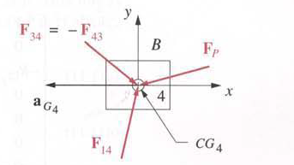

Figure 17 Free Body Diagram for Link 4

Equations for link 4

### Torque.

Torque is a quantitative measure of the tendency of a force to cause or change rotational motion.

Torque (also called a moment) is the term we use when we talk about forces that act in a rotational manner. You apply a torque or moment when you turn a dial, flip a light switch, drill a hole, tighten a screw or bolt, or in this case rotate a motor.

In order to effectively design with D.C. motors, it is necessary that we understood their characteristic curves. For every motor, there is a specific Torque/Speed curve and Power curve.

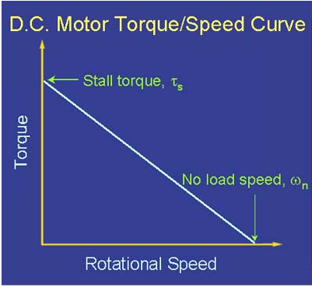

Figure 18 Torque/Speed Curve of A Typical D.C. Motor.

The graph above shows a torque/speed curve of a typical D.C. motor. Note that torque is inversely proportional to the speed of the output shaft. In other words, there is a *tradeoff* between how much torque a motor delivers, and how fast the output shaft spins. Motor characteristics are frequently given as two points on graphs:

* The stall torque,[Ts], represents the point on the graph at which the torque is a maximum, but the shaft is not rotating.
* The no load speed,[Wn] is the maximum output speed of the motor (when no torque is applied to the output shaft).

The curve is then approximated by connecting these two points with a line, whose equation can be written in terms of torque or angular velocity as seen in the equations below:

|  |
| --- |
| The linear model of a D.C. motor torque/speed curve is a very good approximation. The torque/speed curves shown below are actual gotten from the working model 2D prototype design Note that the characteristic torque/speed curve for this motor is linear.  This is generally true as long as the curve represents the direct output of the motor, or a simple gear reduced output. If the specifications are given as two points, it is safe to assume a linear curve.. This linear line graph will continually accelerate in a straight line.  .  Figure 19 Working Model 2D Motor Rotation. |

## Implementation of Task 4. Working Model 2D.

Working Model (WM) is an engineering simulation software product by Design Simulation Technologies. Virtual mechanical components, such as springs, ropes, and motors are combined with objects in a 2D working space. After the software is run, the program will simulate the interaction of the model's parts and can also graph the movement and force on any element in the project. It is useful for basic physics simulations, and can be quite a powerful dynamic geometric analytical tool, once you learn it.

The working model simulation is used to verify the kinetic and kinematic Matlab results.

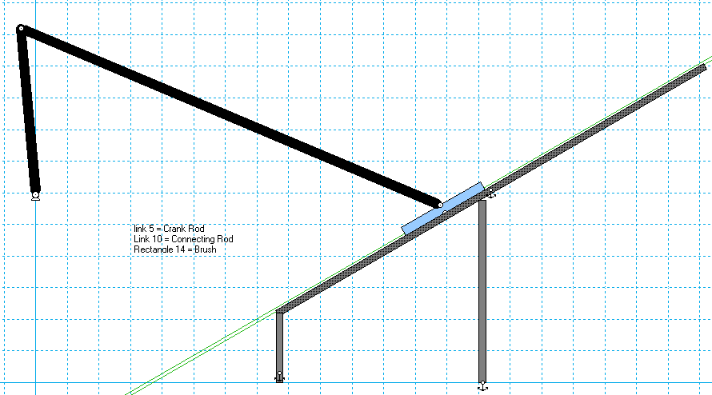

Figure 20 Design Schematic Simulation on Working Model 2D

Vx = Velocity along the x axis.

Px = Position along the x axis.

Ax = Acceleration along the x axis.

Vy = Velocity along the y axis.

Py = Position along the y axis.

Ay = Acceleration along the y axis.

|V|, |P|, |A| = The speed.

Vø = Angular velocity of the vehicle.     
Pø = Angular position of the vehicle.

Aø = Angular acceleration of the vehicle

## Implementation of Task 5. Design Formation.

## Implementation of Task 6. Computer Aided Design.

## Implementation of Task 7. FEM Stress Analysis.

## Implementation of Task 8. Finite Element Method Stress Analysis.

1. Conclusion.

The effects of presence of dust were studied using falling leaves, dust, bird dropping. The dust has a major impact on the efficiency and performance of the solar panel. The reduction in the peak power generates can be up to 10 to 30%. By the observation, it is observed that power reduction due to dust accumulated on the panel and it can be improved by using the cleaning method, there is increase in power and efficiency of solar panel. This is easily maintainable and low of cost. Power consumption is also less for this process. Finally results showed that reduction in the peak power generated.

During our first semester in senior design we have made great progress in our advancement towards developing our automatic solar panel debris removing system. By the end of senior design, our goal is to have our system designed, built, and tested to clean solar panels. So far, this project has been an intense learning experience for this group. We have had to overcome many trials and tribulations to achieve success in our project. One of our biggest complications were identifying a project. A lot of time was spent, during the first half of the semester, trying to identify a project suitable for this class. Since so much time was spent identifying a project, it left a lot less time in the semester to work on the project. This project showed us that anything is possible with a good plan, guidance and challenging work.

In the upcoming semester, our engineering team has mapped out what our next steps should be in order to complete our project in entirety. The next step in our main tasks include power calculations for the system, rover stability, prototyping the system, and delivery. This experience has really shaped us as engineers, helping us grow mentally and preparing both of us for very successful careers in the engineering field. We are happy to be experiencing this senior design class with students that really help drive our passion for engineering. We are very egger to continue our next steps working on our project and have high hopes for the progress to come soon.

Acknowledgement

Dr. Payam Matin – Mechanical Engineering Associate Professor

Justin Derickson – Electrical Engineering Student

Appendix

You can put reference info here, including: i) specs of components used in the system, ii) source code (must be here but not in the body text), iii) CAD figures, etc.

1. Component Specs
2. Specs of Arduino Due

...

1. Specs of Raspberry Pi

…

1. Source Code.
2. Source Code of Graphic User Interface

…

1. Source Code of Robotic Arm

…

REFERENCES

[1] *Abaqus/CAE User's Guide (6.13)*, license.mech.northwestern.edu:2080/v6.13/books/usi/default.htm?startat=pt05ch44s02hlb10.html.

[2] Kövecses, József. “Dynamics of Mechanical Systems and the Generalized Free-Body Diagram-Part II: Imposition of Constraints.” *Journal of Applied Mechanics*, American Society of Mechanical Engineers, 1 Nov. 2008, appliedmechanics.asmedigitalcollection.asme.org/article.aspx?articleid=1474387.

[3] Mabie, H.H., and Reinholtz, C.F., Mechanisms and Dynamics of Machinery (4th Ed.), John Wiley & Sons. 1987.

[4] Logan, Daryl l. *A First Course in Finite Element Method*. 4th ed.

[5] Norton, Robert L. *Machine Design: an Integrated Approach*. Prentice Hall, 2014.

[6] “5.5. Illustrative Problems.” *StudFiles*, studfiles.net/preview/4494350/page:4/.

http://lancet.mit.edu/motors/motors3.html#torque